**Sprint-4**

|  |  |
| --- | --- |
| **Date** | **6 November 2022** |
| **Team Id** | **PNT2022TMID13490** |
| **Project Name** | **Gas Leakage Monitoring and Alerting System** |

**Notification :**

int redLed = 13; int greenLed = 12; int yelloled = 9; int buzzer = 11; int smokeA0 = A0; void setup()

{

pinMode(redLed, OUTPUT); pinMode(greenLed, OUTPUT); pinMode(yelloled, OUTPUT); pinMode(buzzer, OUTPUT); pinMode(smokeA0, INPUT);

Serial.begin(9600);

}

void loop() { int analogSensor = analogRead(smokeA0);

Serial.print("Gas Level: "); Serial.println(analogSensor); if (analogSensor > 682 && analogSensor < 719)

{

digitalWrite(yelloled, HIGH); digitalWrite(greenLed, LOW); digitalWrite(redLed, LOW); tone(buzzer, 3000, 200);

}

else if(analogSensor > 720)

{

digitalWrite(redLed, HIGH); digitalWrite(greenLed, LOW); digitalWrite(yelloled, LOW); tone(buzzer, 1000, 200);

}

else

{

digitalWrite(redLed, LOW); digitalWrite(greenLed, HIGH); digitalWrite(yelloled, LOW); noTone(buzzer);

} delay(100);

}

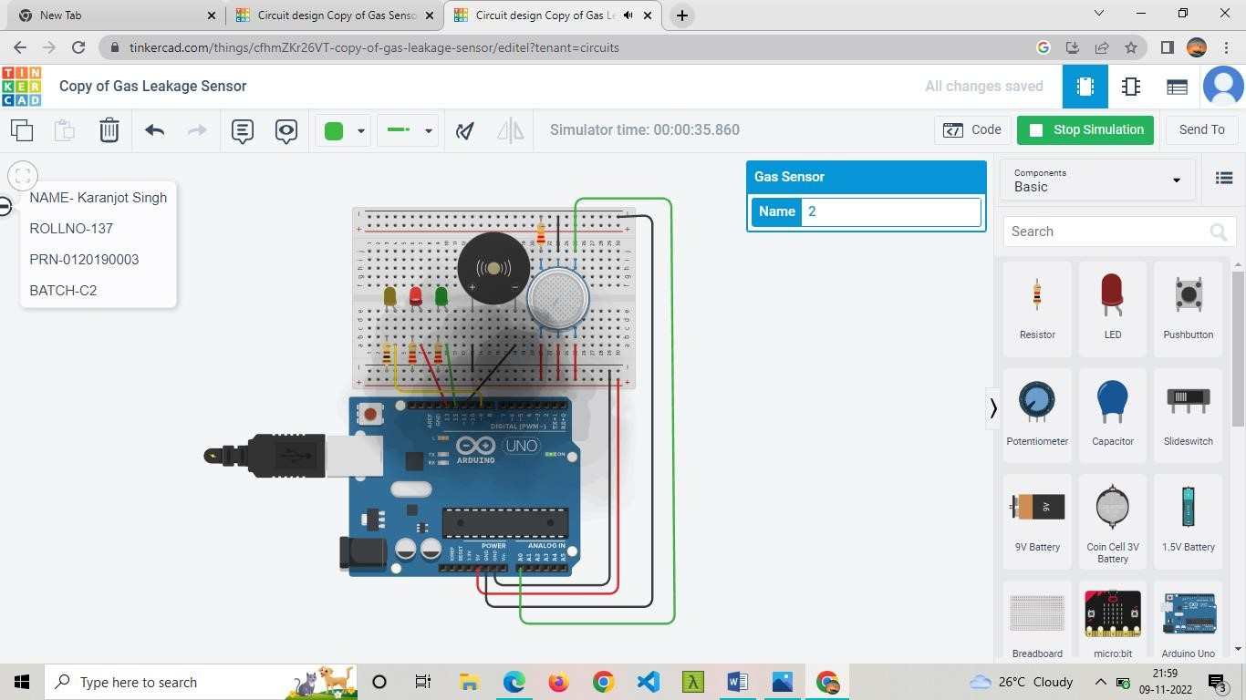

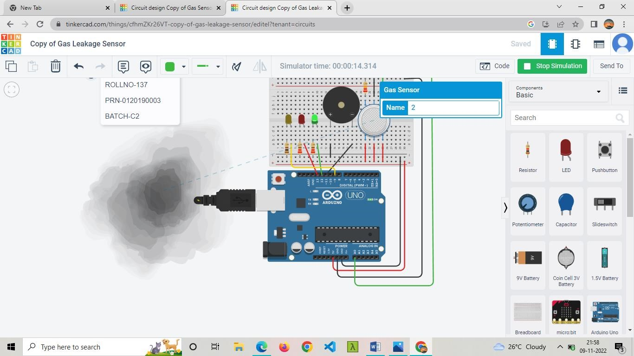

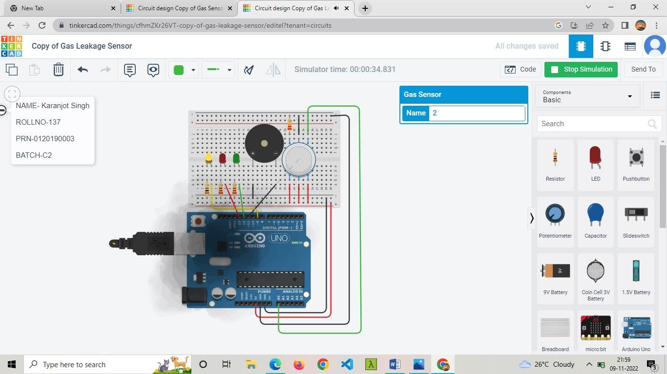

The gas leakage detected by the model can be notification SMS or alarming system. According to the range the three lights of yellow, red and green light will blink for alerting.